**Objective:**

To blink 3 LED by using an IC in microcontroller.

**Instrument Required:**

1. PIC16F873
2. Switch (3)
3. LED (3)

**Circuit Diagram:**

**Source Code:**

void main()

{

trisb = 0b00000111;

portb = 0b00000000;

trisc = 0b00000000;

portc = 0b00000000;

while(1)

{

if(portb.f0 == 1)

{

portc = 0b00000001;

}

if(portb.f1 == 1)

{

portc = 0b00000010;

}

if(portb.f2 == 1)

{

portc = 0b00000100;

}

}

}

**Schematic Diagram:**

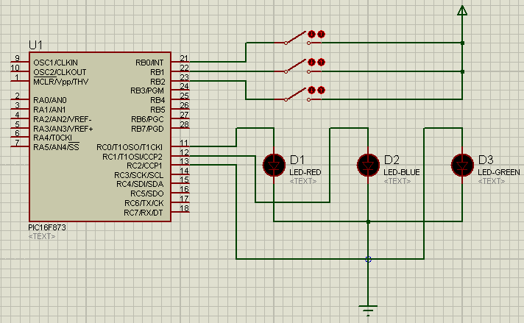

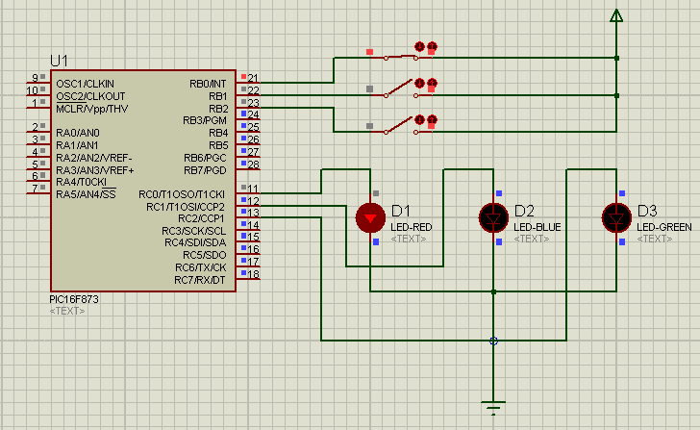

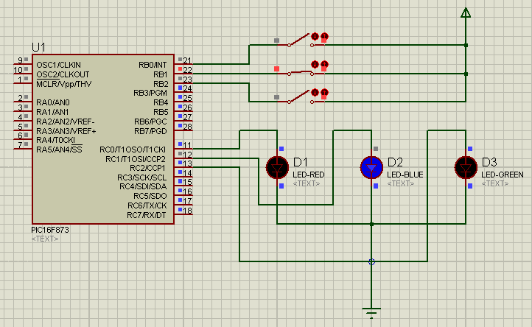

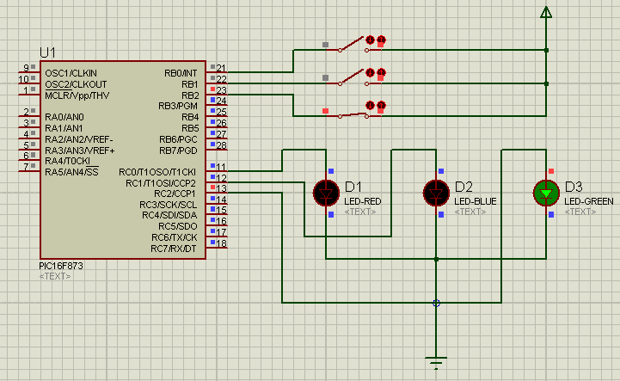

**Conclusion:**

In the end, we have